EXPT NO: 2 | COMPARATIVE STUDY OF ACTIVATION FUNCTIONS AND OPTIMIZATION ALGORITHMS IN DEEP LEARNING
DATE: 20/07/2026

PRE-LAB QUESTIONS (PROVIDE BRIEF ANSWERS TO THE FOLLOWING QUESTIONS)

- What is the purpose of an activation function in an Artificial Neural Network?

An activation function introduces non-linearity into a neural network, allowing it to learn complex patterns and decide how much information should be passed to the next layer.

- Differentiate between the Sigmoid, Tanh, and ReLU activation functions based on their output range and mathematical properties.

Feature | Sigmoid | Tanh | ReLU
Output Range | 0 to 1 | -1 to 1 | 0 to ∞
Vanishing Gradient | High | Moderate | Very Low (positive side)
Training Speed | Slow | Faster than Sigmoid | Fastest
Computational Cost | Higher | Higher | Very Low
Common Use | Binary output layer | Hidden layers (older models) | Hidden layers (modern networks)

- Why is an optimization algorithm required during neural network training?

An optimization algorithm is required to minimize the loss function by updating the weights and biases of a neural network during training. It helps the model learn from errors, improve prediction accuracy, and converge toward the optimal solution efficiently.

- What is the difference between Batch Gradient Descent, Stochastic Gradient Descent (SGD), and Mini-Batch Gradient Descent?

Feature | Batch GD | SGD | Mini-Batch GD
Data Used | Entire dataset | One sample | Small batch
Weight Updates | Once per epoch | After every sample | After every batch
Speed | Slow | Fast | Moderate
Stability | Very Stable | Noisy | Stable

- Explain the role of Google Colab and GitHub in deep learning experiment management.
Google Colab provides a cloud-based environment for developing and training deep learning models with free GPU/TPU support, easy access, and automatic integration with Google Drive.

GitHub is used for version control, code backup, collaboration, and maintaining project documentation, ensuring that deep learning experiments are reproducible and well organized.

AIM
To analyze the impact of different activation functions and optimization algorithms on the performance of Artificial Neural Networks (ANNs) and to learn best practices for managing deep learning experiments using cloud-based tools and version control.

SOFTWARE REQUIREMENTS
- Python
- TensorFlow or PyTorch
- Google Colab
- GitHub
- Matplotlib

OBJECTIVES
Students will be able to:
- Understand the role of activation functions in neural networks.
- Visualize and compare commonly used activation functions.
- Evaluate the performance of different activation functions in ANN models.
- Analyze various gradient-based optimization algorithms.
- Compare optimizer convergence and model accuracy.
- Learn experiment management using Google Colab, Google Drive, and GitHub.
- Maintain reproducible deep learning experiments using version control.

GITHUB LINK: https://github.com/Akhil-coderr/24BAD007-DEEP-LEARNING-24ADI006.git

PROCEDURE
PART A: VISUALIZATION OF ACTIVATION FUNCTIONS
Implement and plot the following activation functions:
- Sigmoid
- Tanh
- ReLU
Compare their:
- Output range
- Saturation regions
- Gradient behavior
- Computational efficiency
- Typical applications

TASK A:
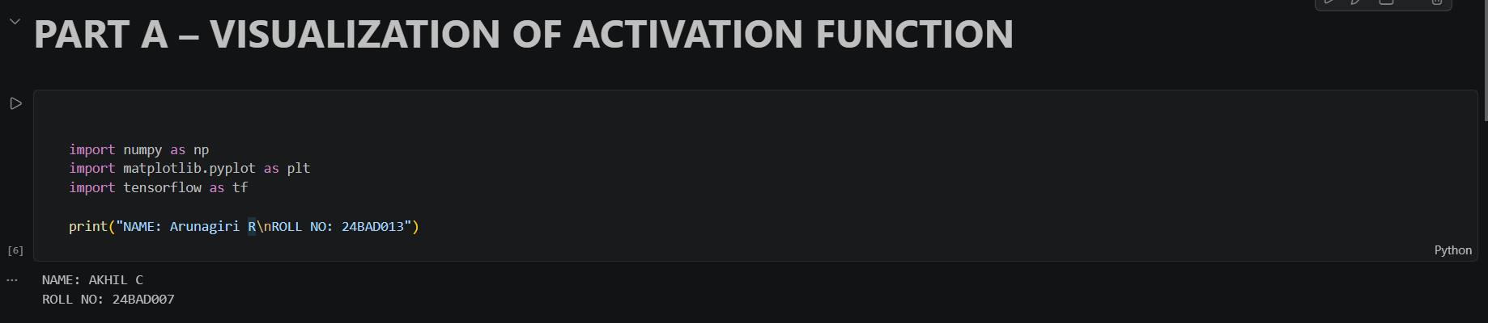
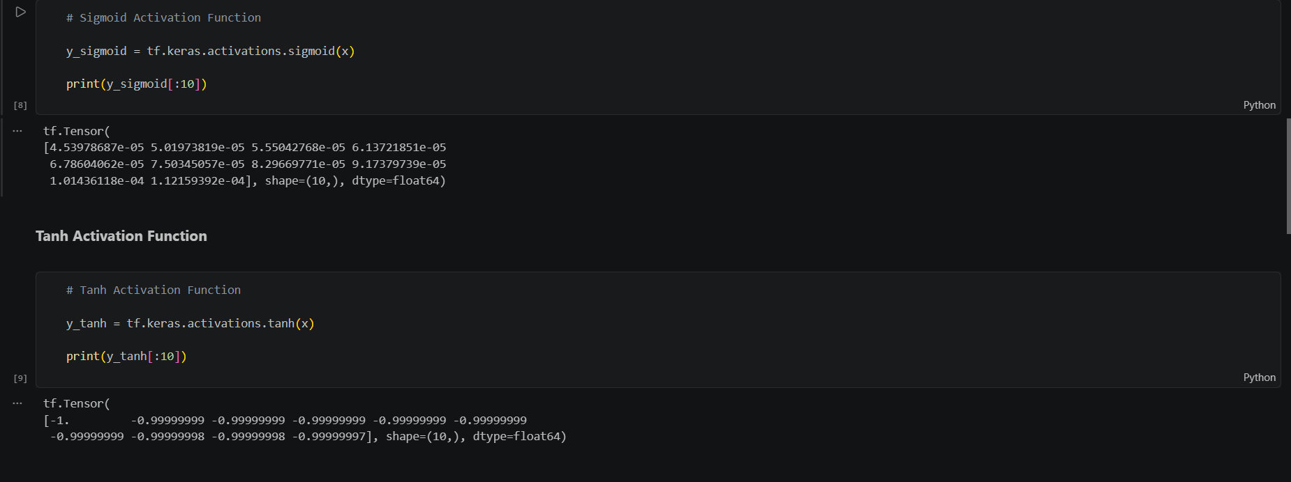
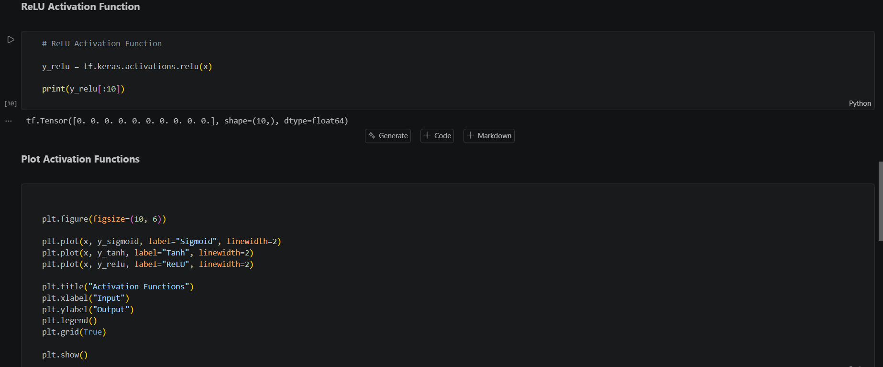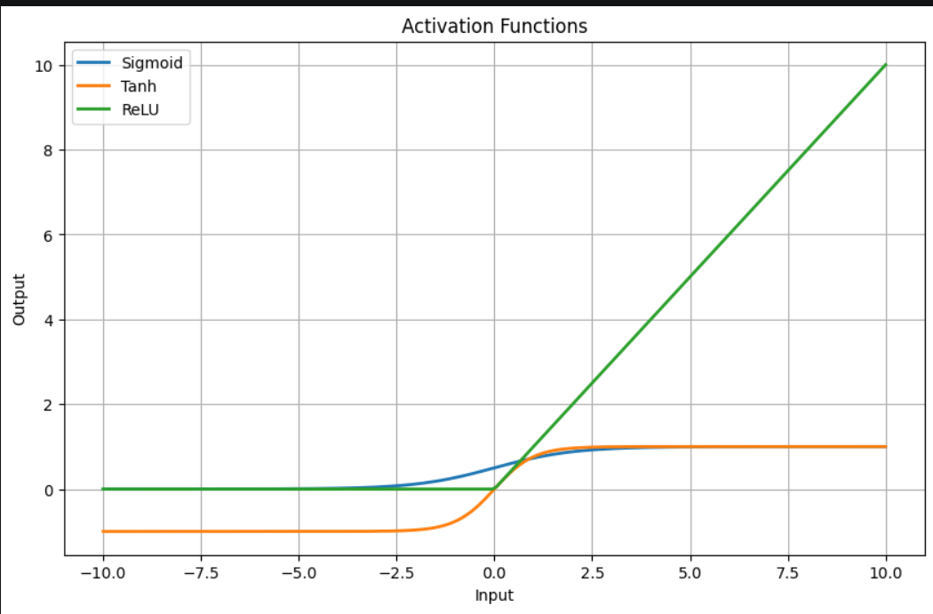

PART B: PERFORMANCE COMPARISON OF ACTIVATION FUNCTIONS

Train identical ANN architectures using:
- Sigmoid
- Tanh
- ReLU
Record and compare:
- Training accuracy
- Validation accuracy
- Training loss
- Validation loss
- Number of epochs required for convergence
Analyze which activation function performs best and justify the observations.

TASK B:

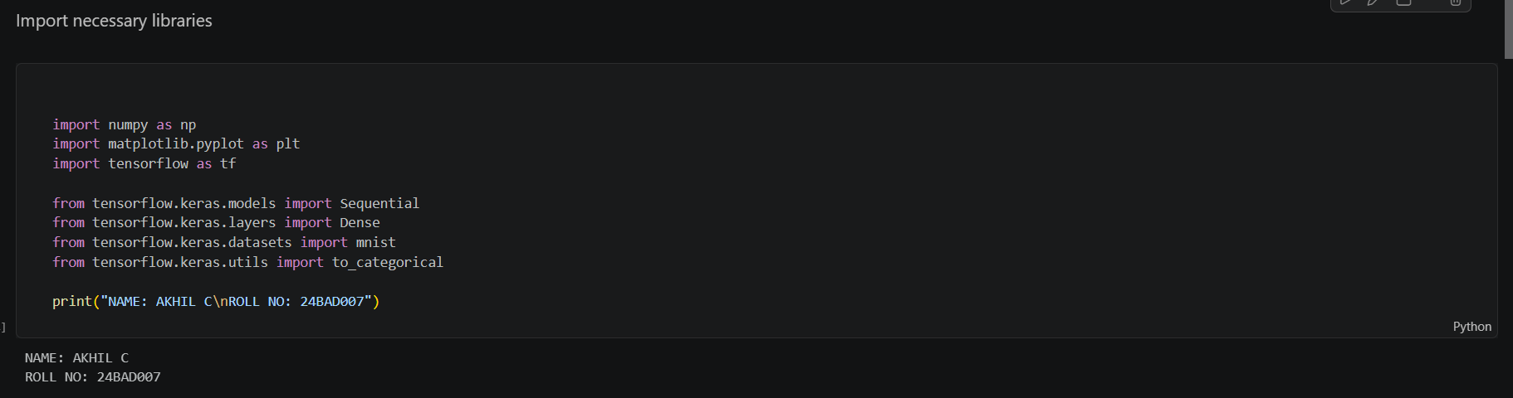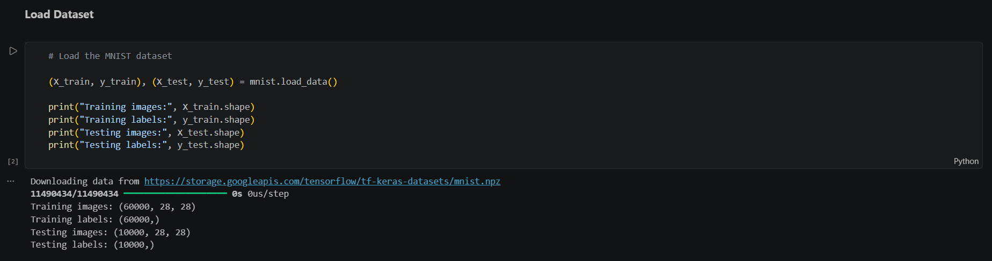
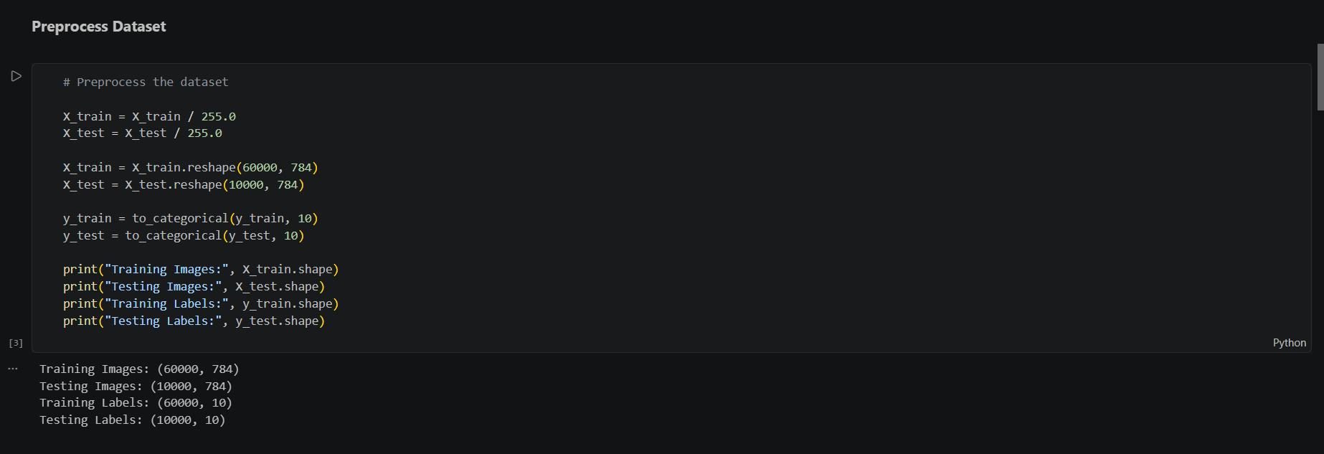
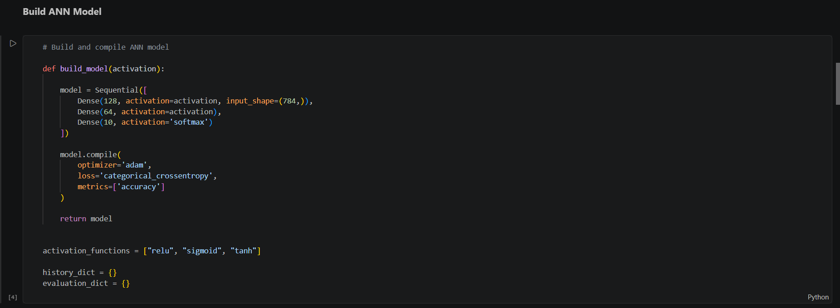

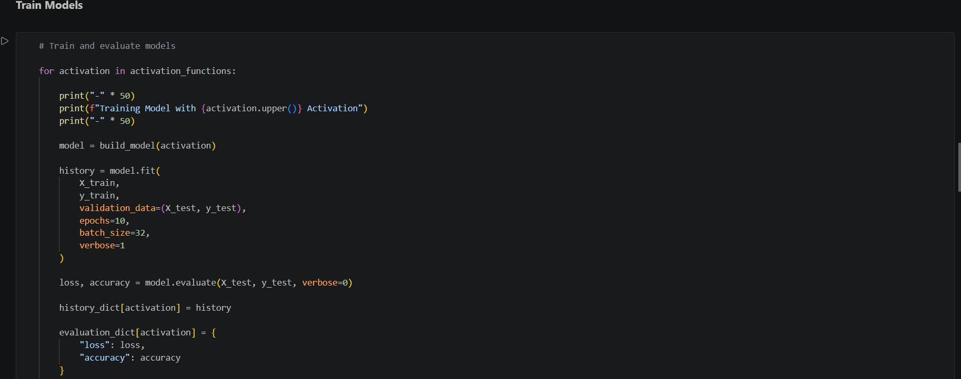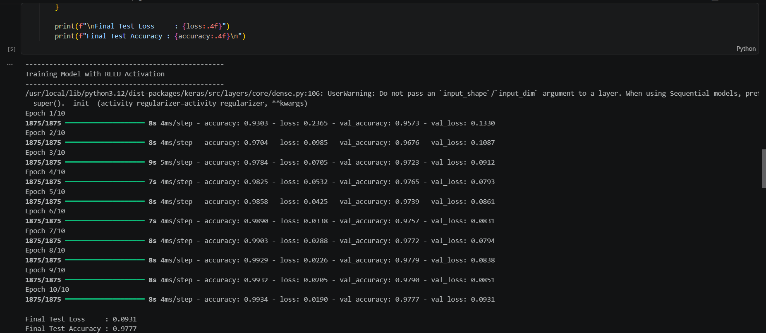

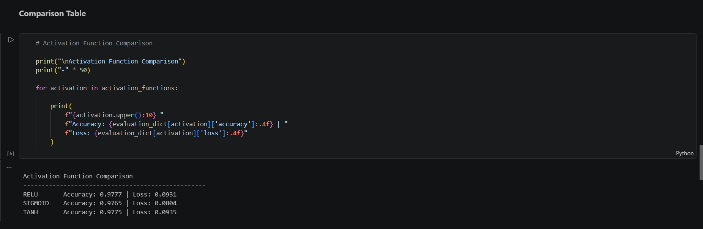

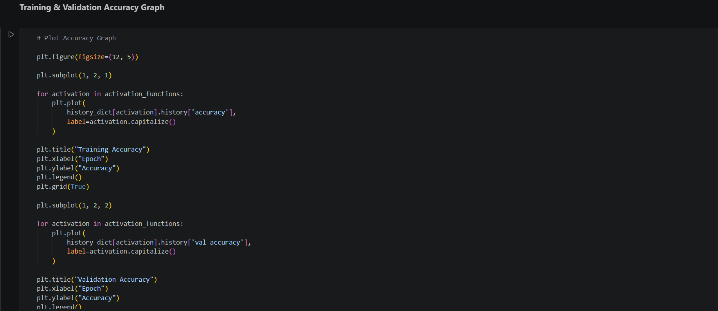

PART C: COMPARISON OF OPTIMIZATION ALGORITHMS

Train the same ANN using:
- Stochastic Gradient Descent (SGD)
- Momentum
- RMSProp
- Adam
Compare:
- Training loss
- Validation loss
- Convergence speed
- Final training accuracy
- Final validation accuracy
Visualize:
- Loss vs Epoch
- Accuracy vs Epoch
Discuss which optimizer converges faster and produces better generalization.

TASK C:

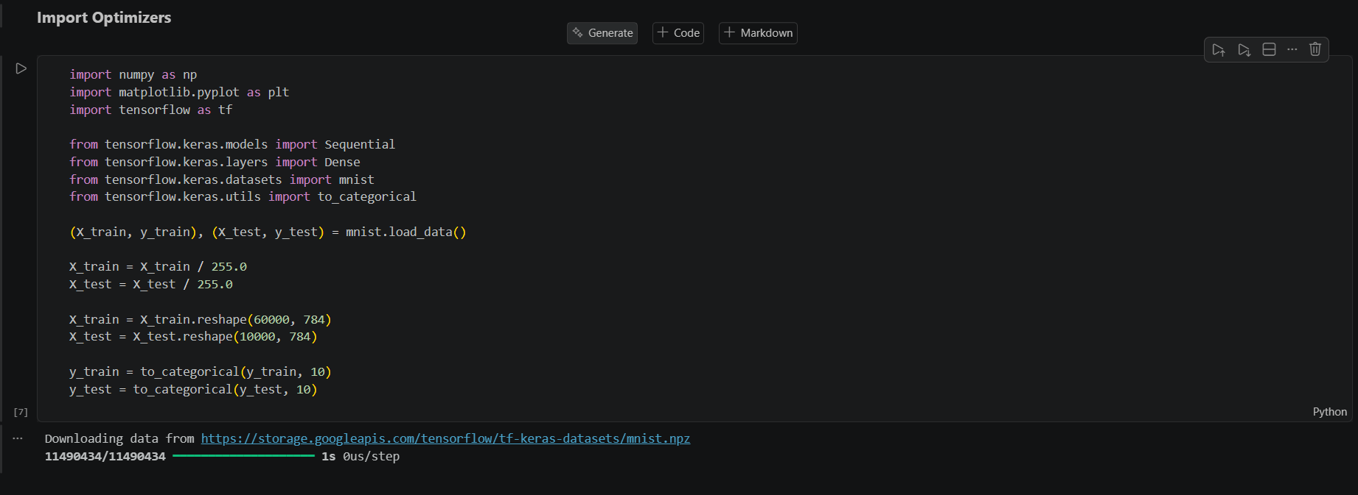

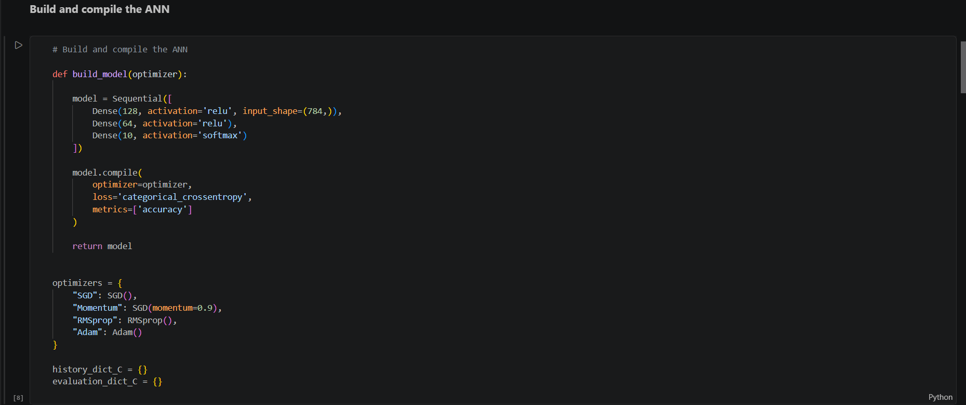
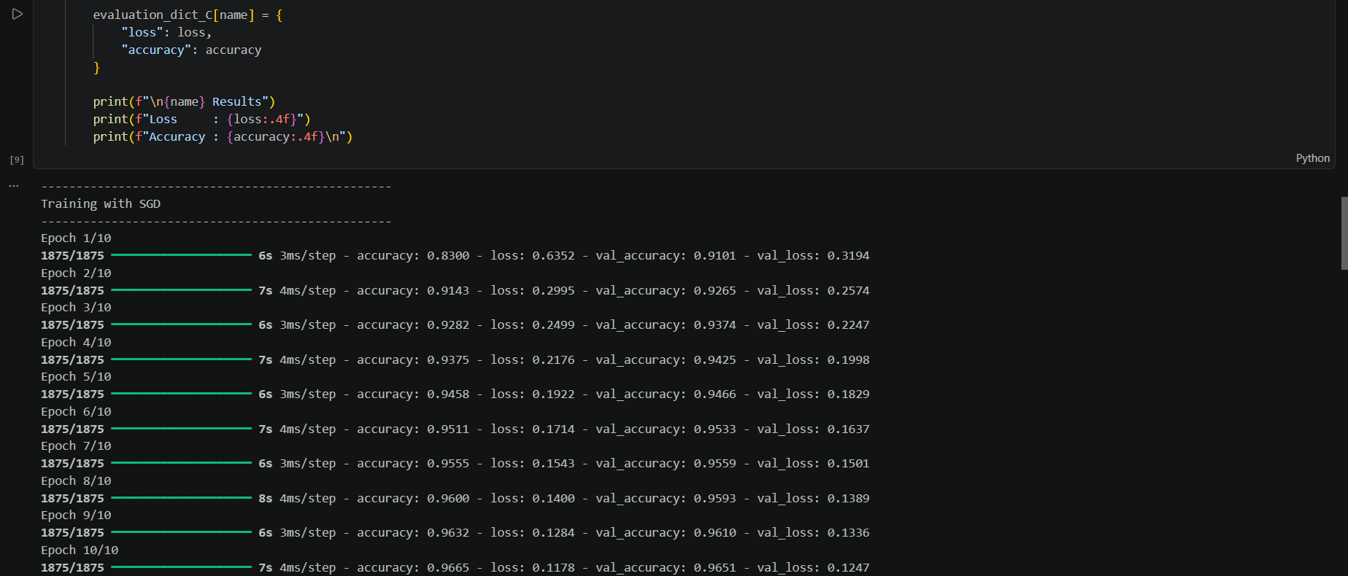

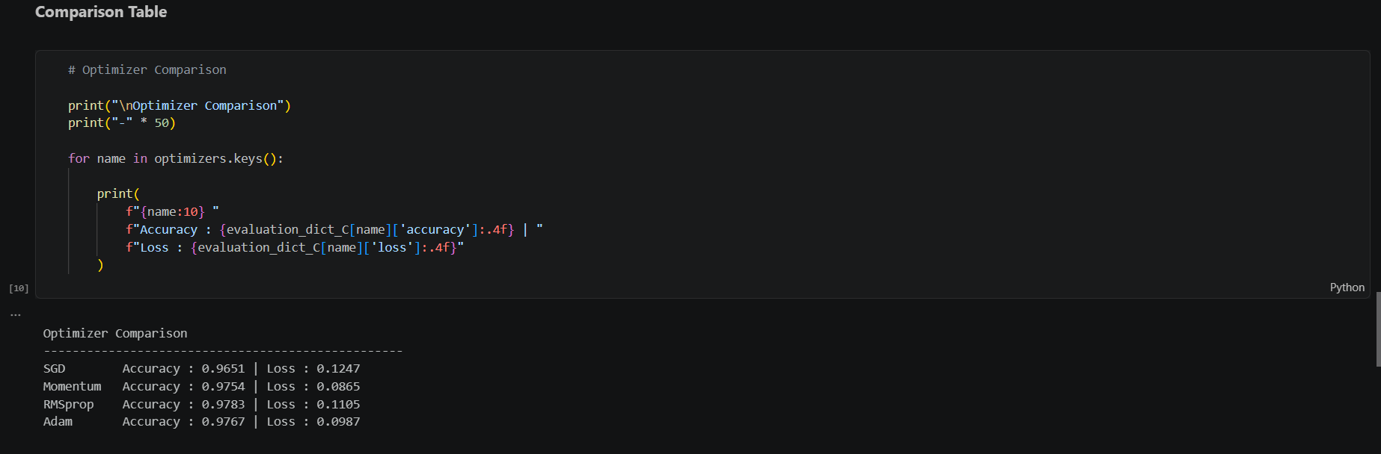

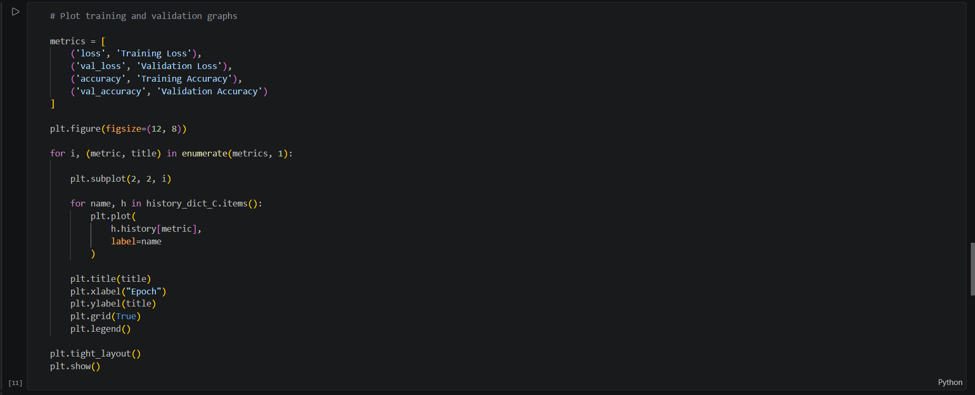

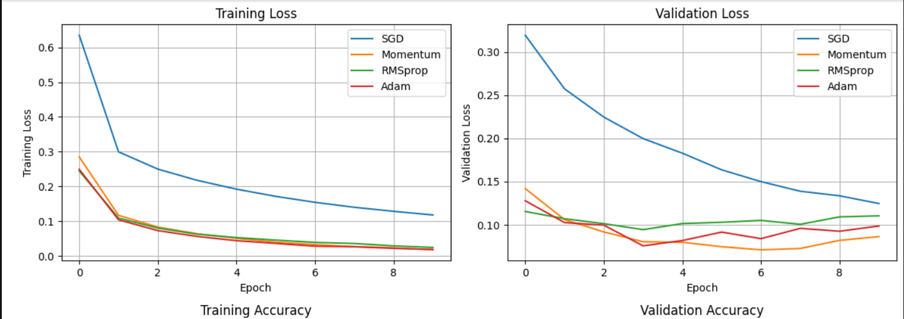

PART D: DEEP LEARNING EXPERIMENT MANAGEMENT
Perform the following tasks:
- Create a Google Colab notebook.
- Mount Google Drive.
- Save notebooks and trained models.
- Create a GitHub repository.
- Upload notebooks to GitHub.
- Commit changes and maintain version history using Git.
- Document the experiment using a README.md file.

TASK D:

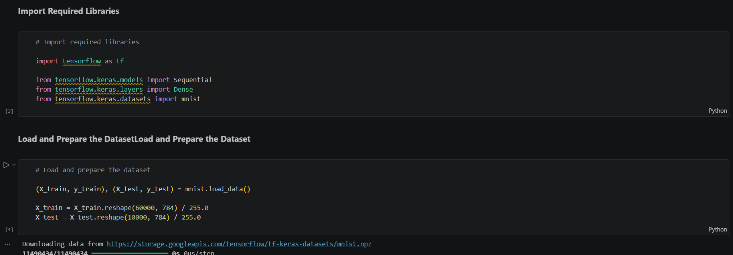

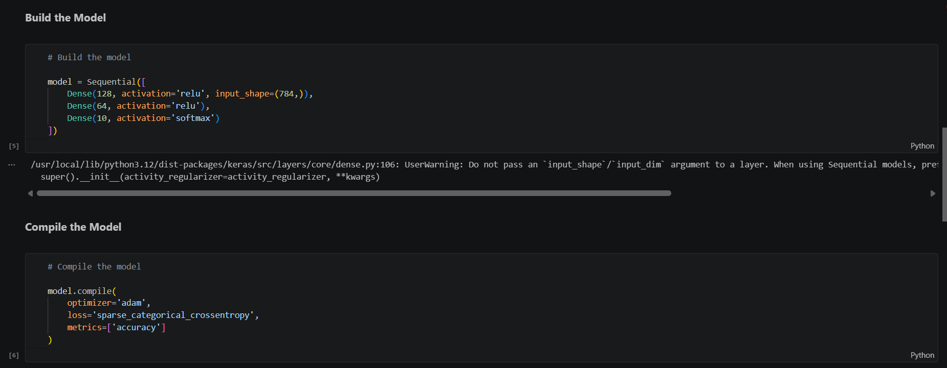

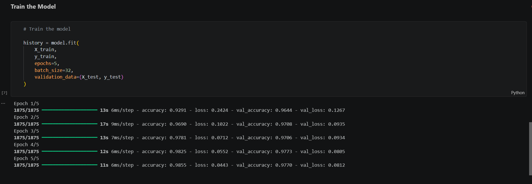
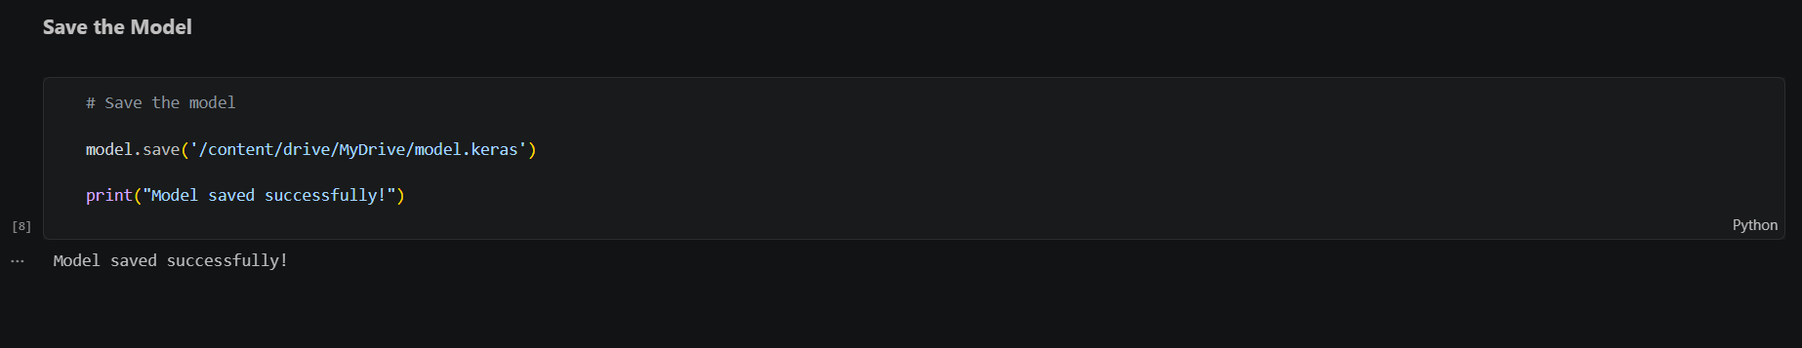

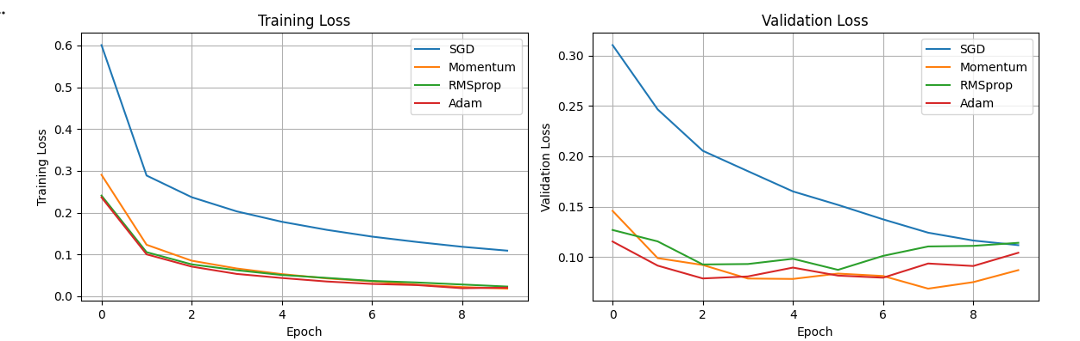

EXPECTED OUTCOME
Students will understand how activation functions and optimization algorithms influence neural network learning and performance. They will also gain practical experience in organizing, documenting, and maintaining reproducible deep learning experiments using cloud platforms and Git-based version control.

POST-LAB QUESTIONS (PROVIDE BRIEF ANSWERS TO THE FOLLOWING QUESTIONS)

- Which activation function achieved the best performance in your experiment? Justify your answer using the obtained results.

ReLU achieved the best overall performance in the experiment with the highest accuracy of 98.04% (0.9804). Sigmoid achieved 97.99% (0.9799) accuracy with a loss of 0.0701, while Tanh achieved 97.63% (0.9763) accuracy with a loss of 0.0851. Therefore, ReLU was the best activation function due to its highest accuracy and faster convergence.

- Compare the convergence behavior of SGD, Momentum, RMSProp, and Adam based on the training graphs.

Adam showed the fastest convergence with the lowest loss and highest accuracy. RMSProp also performed well with similar results. Momentum converged faster than SGD, while SGD had the slowest convergence with higher loss and lower accuracy. Therefore, Adam was the best optimizer in this experiment.

- Why does the ReLU activation function generally train faster than the Sigmoid activation function?

ReLU generally trains faster than Sigmoid because it avoids the vanishing gradient problem for positive inputs, allowing faster learning and better gradient flow. In contrast, the Sigmoid function saturates for large positive or negative values, resulting in slower training and convergence.

- How does version control using GitHub improve the reproducibility and collaboration of deep learning projects?

GitHub improves reproducibility by maintaining version history and allowing experiments to be tracked and reproduced. It also enables collaboration by allowing multiple developers to share, review, and update code efficiently.

- If you were asked to train a deep neural network for an image classification task, which activation function and optimizer would you choose? Justify your selection based on the experimental observations.

Based on the experimental results, I would choose the ReLU activation function and the Adam optimizer for an image classification task. ReLU achieved the highest accuracy, while Adam showed the fastest convergence with low loss and high accuracy, making them the best combination for efficient and accurate training.

ASSESSMENT
Description | Max Marks | Marks Awarded
Pre Lab Exercise | 5
In Lab Exercise | 10
Post Lab Exercise | 5
Viva | 10
Total | 30
Faculty Signature

